# Predominance Helper 1.0

## What is predominance and how can I use it?

Predominance allows users to compare multiple attributes within a dataset and show the largest (dominant) category and/or value on the map.

A simple example would be a table of geographic areas with 2 columns of attributes: *Males* and *Females*. Predominance would determine the “dominant” gender (Male or Female) in each region.

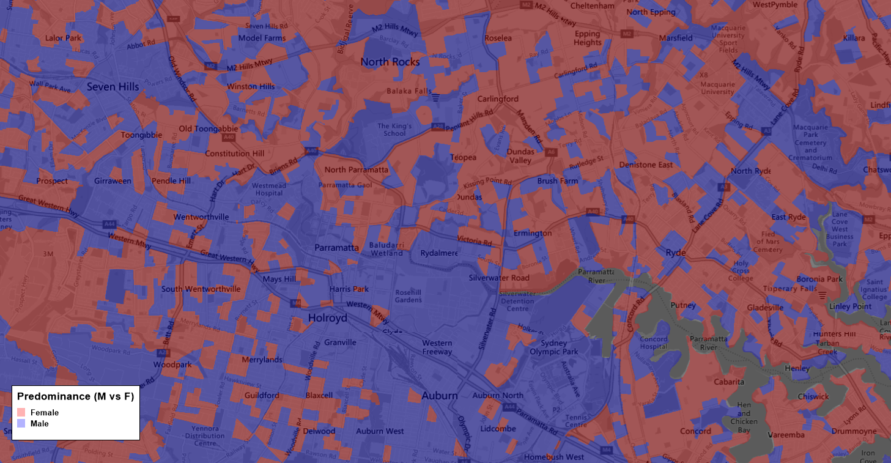

An election map (like the one below by ABC News for the 2020 US Election) is another simple example of a predominance map. On a State-by-State basis, it displays which of two or more candidates have the highest total vote count.

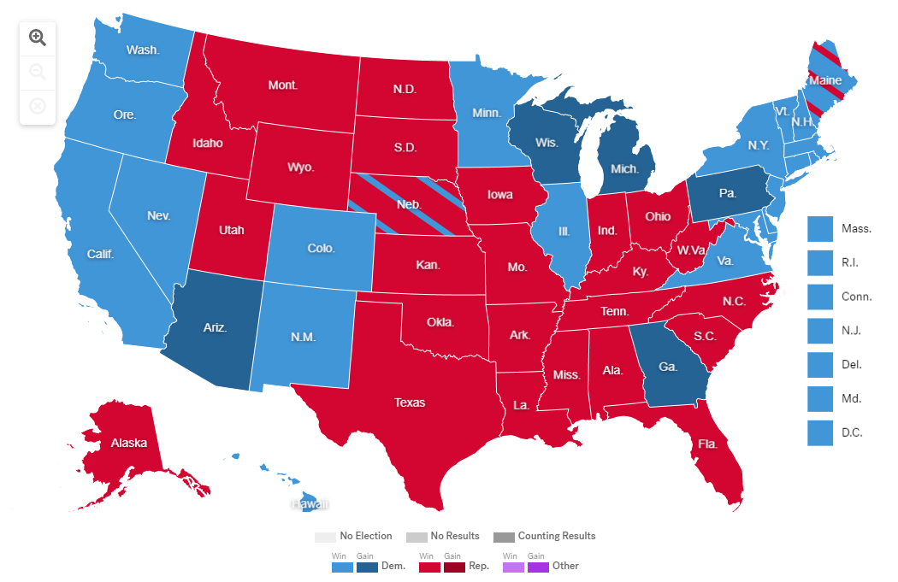

With more and more data becoming available, the question of “which is the dominant attribute” from a row with multiple attributes, and then displaying this attribute on a map is a valuable method for analyzing data and providing data-driven output to an end user.

A predominance map can be applied when there are multiple columns of data that share a common subject and unit of measurement. By using predominance to analyze the multiple columns of related data, a user can determine which column contains the highest, or predominant, value for each geographic feature or reference.

Demographic Data (eg. Census Data) is a prime example of where the value of a predominance analysis could be beneficial. Being able to quickly determine and visualise:

* which Age Band is the most dominant;
* which Income Band is the most dominant; or
* which Profession is the most dominant,

are all simply answered and displayed using the new “Predominance Helper” tool.

The example below illustrates an analysis based on demographic data at a Census geography level to determine which Occupation category is the most dominant in that area. The Predominance Helper tool adds fields for the dominant Category and also the value of that Category (if desired). The resultant Predominance map reflects a clear demarcation across the map-area in terms of “white collar” occupations versus “blue collar” occupations.

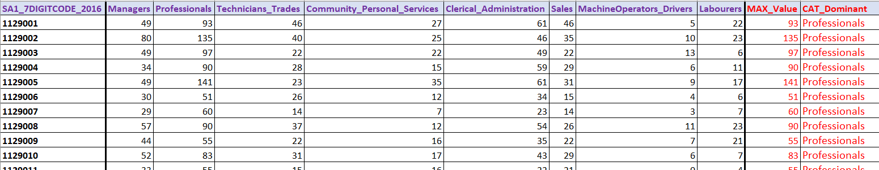

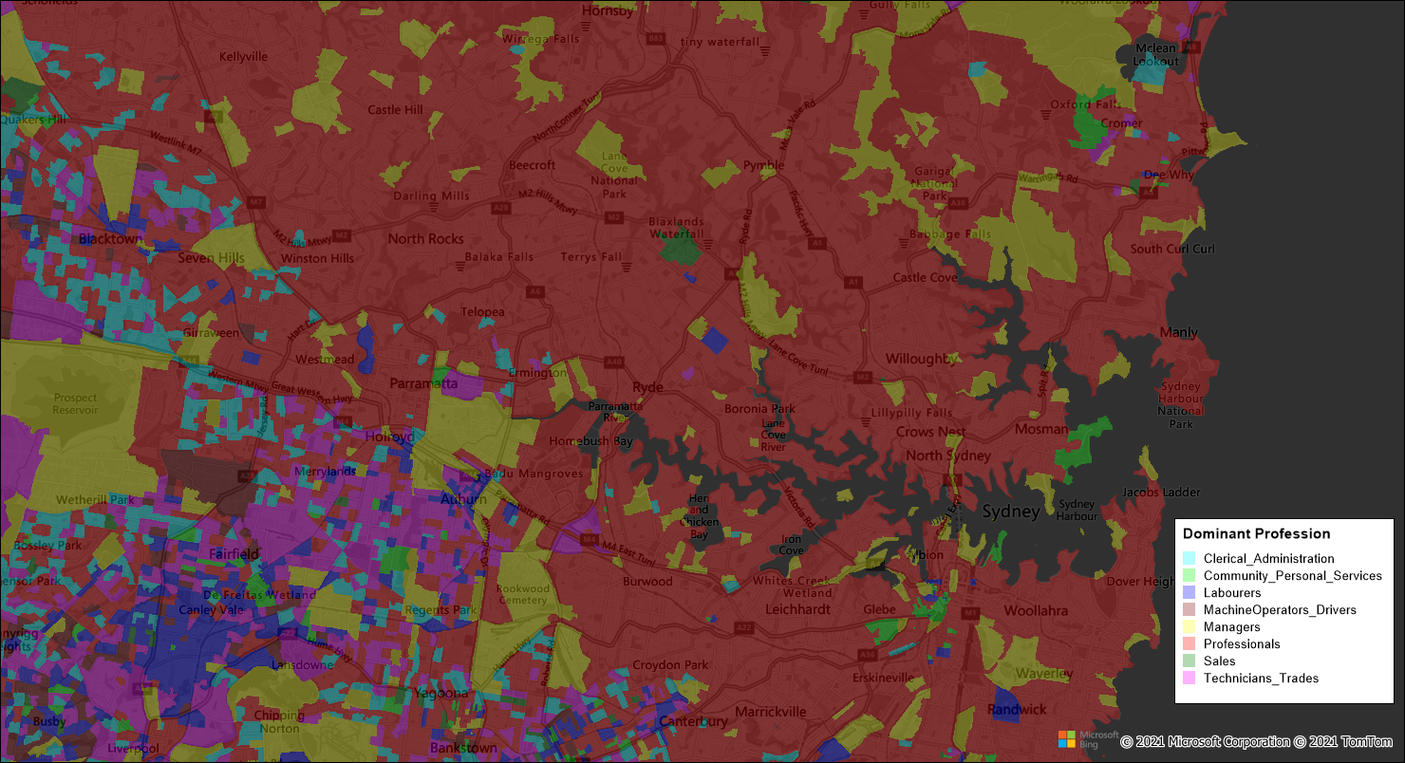

When the Predominance Helper tool creates both the dominant Category of the data being analyzed as well as that categories Value, by turning the data regions into point objects (eg. using the centroids X & Y values) allows a user to generate a bi-variate thematic map using the dominant Category to colour the point and the relevant Value can be reflected in the size of the point object.

The example below displays the dominant “Household Income Band” as an Individual thematic of the dot displayed, and then uses varying size point Range thematic to reflect the Value of the dominant Category.

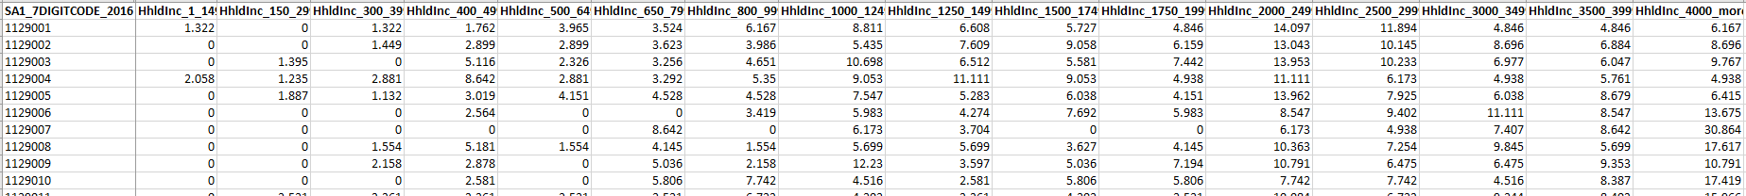

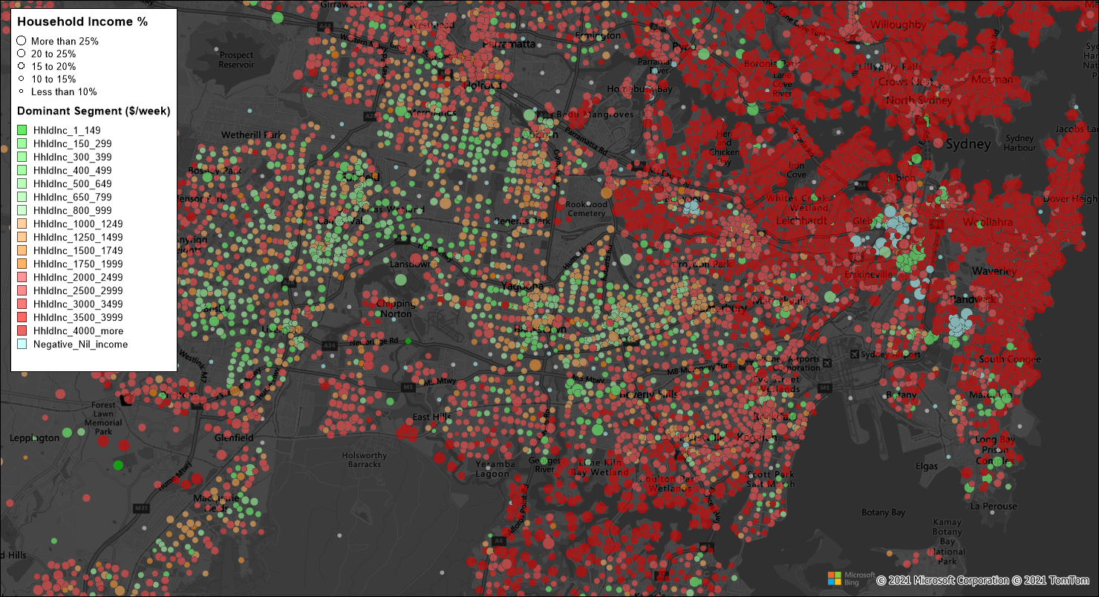

Sales Analysis is another dataset that can benefit from using the Predominance helper tool to deliver an analysis and visualisation to deliver location intelligence outputs that could be otherwsie hidden in amongst the raw data.

In this example, we are determining which brand/model of luxury SUV had the most sales (map displays dominant brand/model by region).

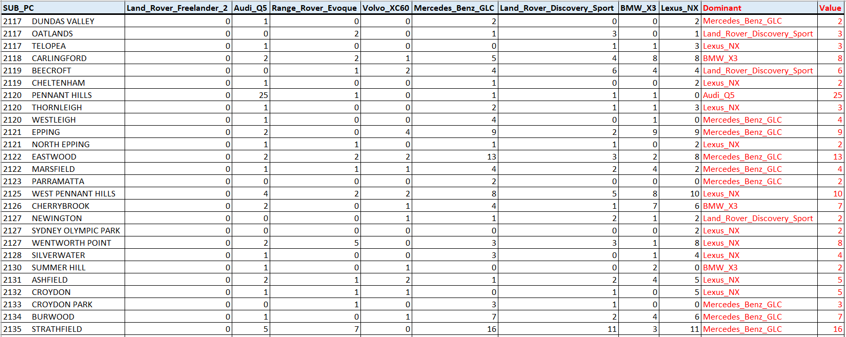

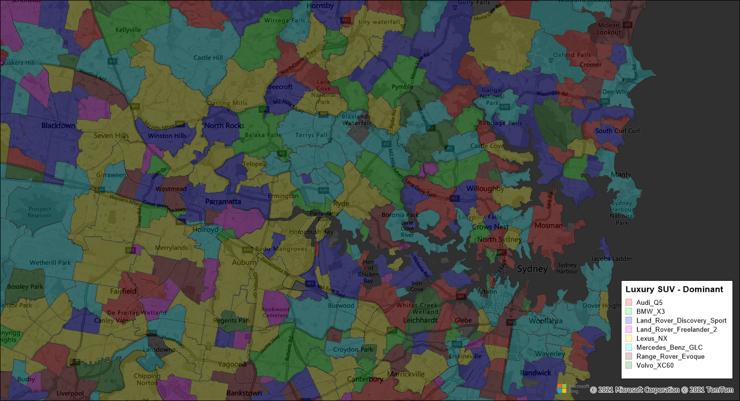

## Using the Predominance Helper tool

***NOTE:*** *Given this tool does modify the table structure consideration should be given to saving a copy of the original data.*

The Predominance Helper tool relies on having a spatially enabled table of data containing multiple numeric variables against each object record.

Access Predominance Helper by going to the TABLE tab and the tool can be found in the “Calculate” group. Click on the icon called “Calculate Predominance”.

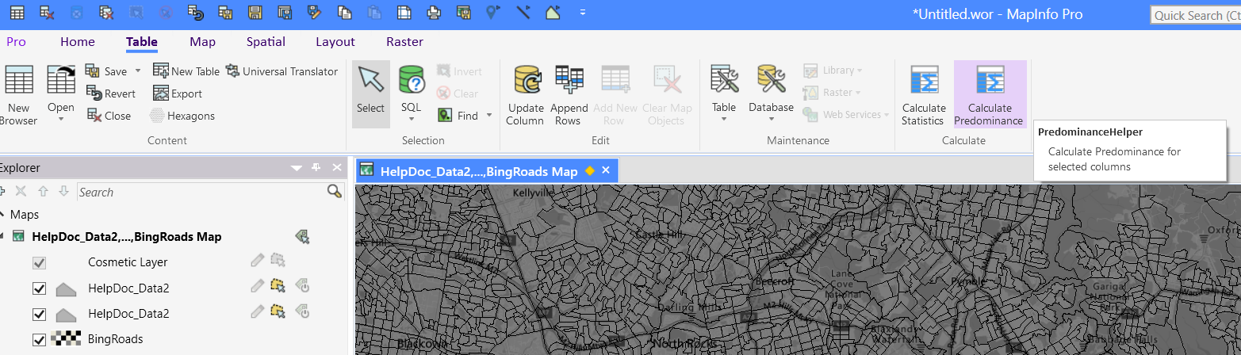

A dialog box will appear allowing the user to choose the relevant table to use and then the desired columns containing the data to be used.

You can use the Open… button to open the table you want to use in case it isn’t already open.

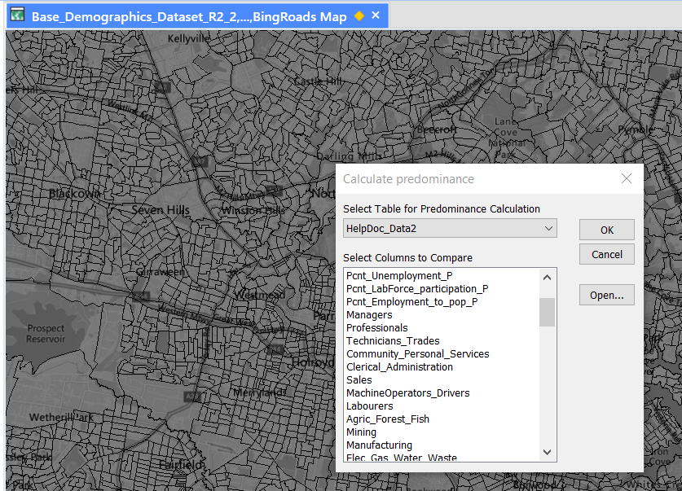 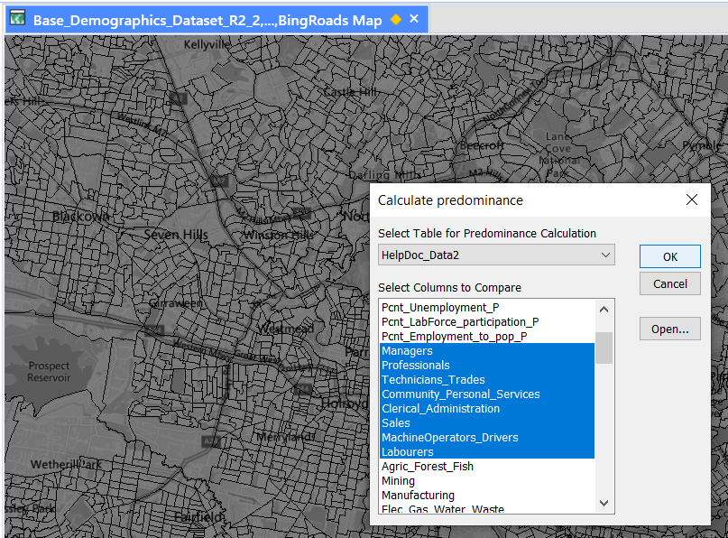

Once the columns have been selected, click OK.

The next screen of the dialog will appear allowing the user to specify a friendlier name for any column name if deemed necessary. By default, the Predominance Helper tool changes three underscores into a dash with a space on each side and a single and two underscores into a space.

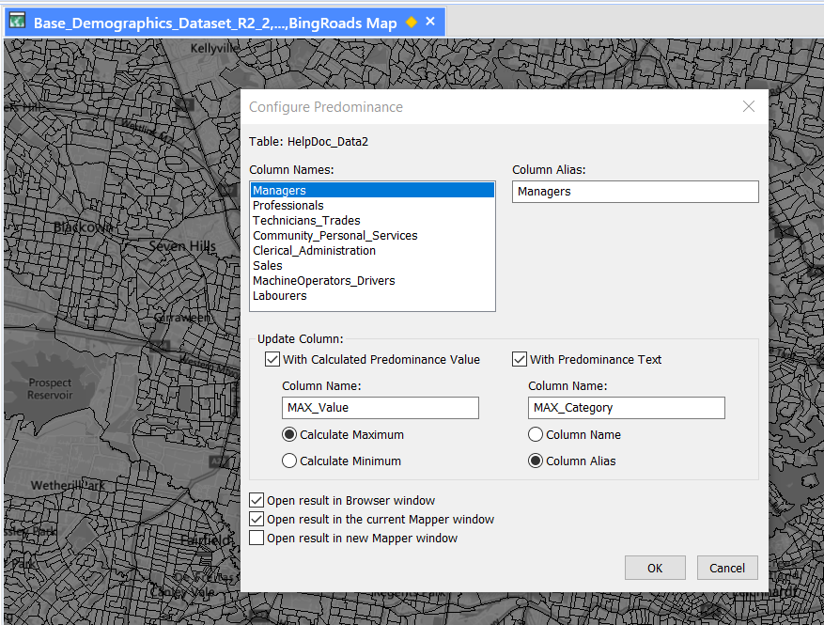

The user then moves down the dialog to the “Update Column” area. Here, the user can choose either or both of two additional fields that will be added to the dataset. Simply check the relevant box if the result is required in the table.

If the columns specified already exist in the table, the content of these will be overwritten without warning.

The “With Calculated Predominance Value” will deliver the maximum or minimum value that is found in the chosen columns of data. The column name can entered here will get updated with the predominant value for each record.

Similarly, the “With Predominance Text” will deliver the column name that contains the maximum (or minimum) value in it. The user can choose to use the original column name or the alias they generated above.

It is then just a matter of choosing how the user wants to have the data presented to them (if at all) by checking any or all of the “Open …..” checkboxes.

Then click OK and when presented with the dialog below, if the user wishes to continue with the process, click Yes. Clicking No reverts the user back to the original state.

If you click No to the question asked here, the predominant value will not get calculated as the needed columns weren’t added.

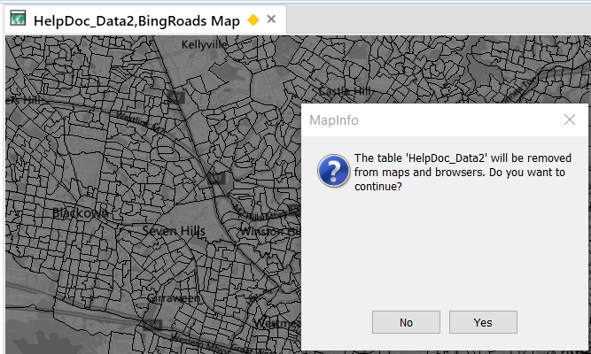

Once the predominance calculations are completed, the user is presented with the table in whichever form they specified in the dialog.

Now it is recommended to save the changes to the table.

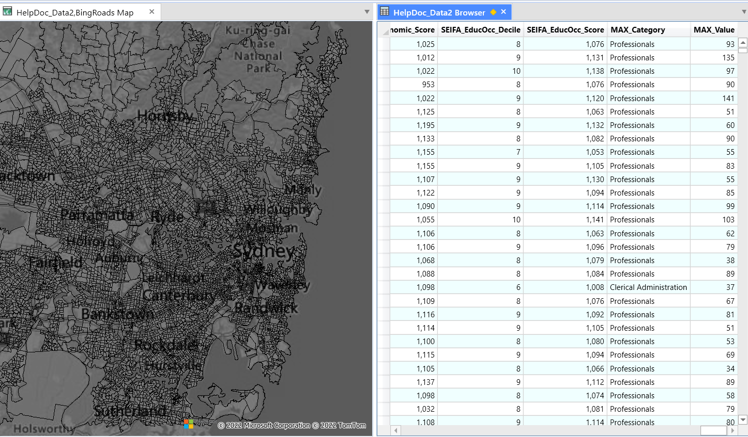

The data in these “predominance” fields can now be used for visualisation or further calculations.

For example a thematic map could be presented which displays the “predominant” category of data from the chosen variables. In the example below, the map displays the distribution by Census Statistical Area 1 of the various “Occupation” types selected from Census data.

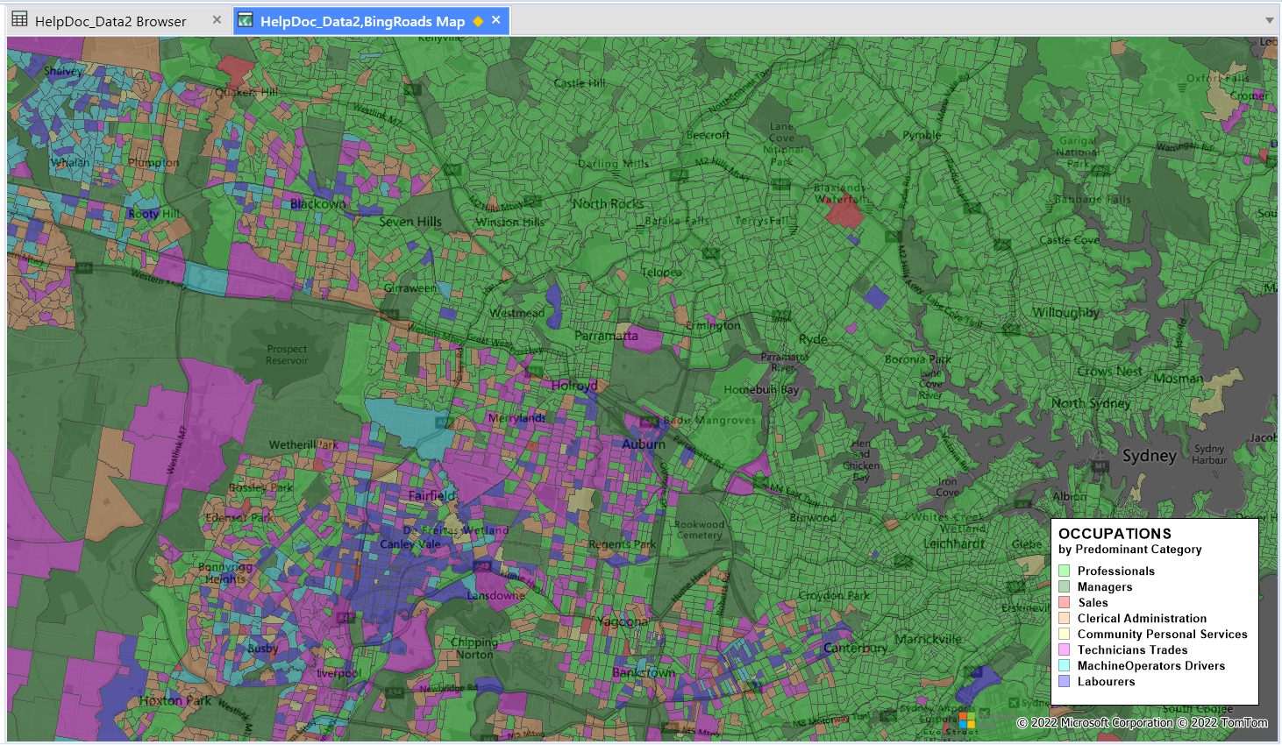

By extension, a copy of the original spatial table with the predominance data (Category and Value) included could be saved.

This copy could then have X/Y fields added (for example, by using the object centroid). These POINTS could then be mapped in bivariate fashion by using the *Category* as the Individual theme and the *Value* as the Point Ranges – Varying Sizes basis.

An example below.

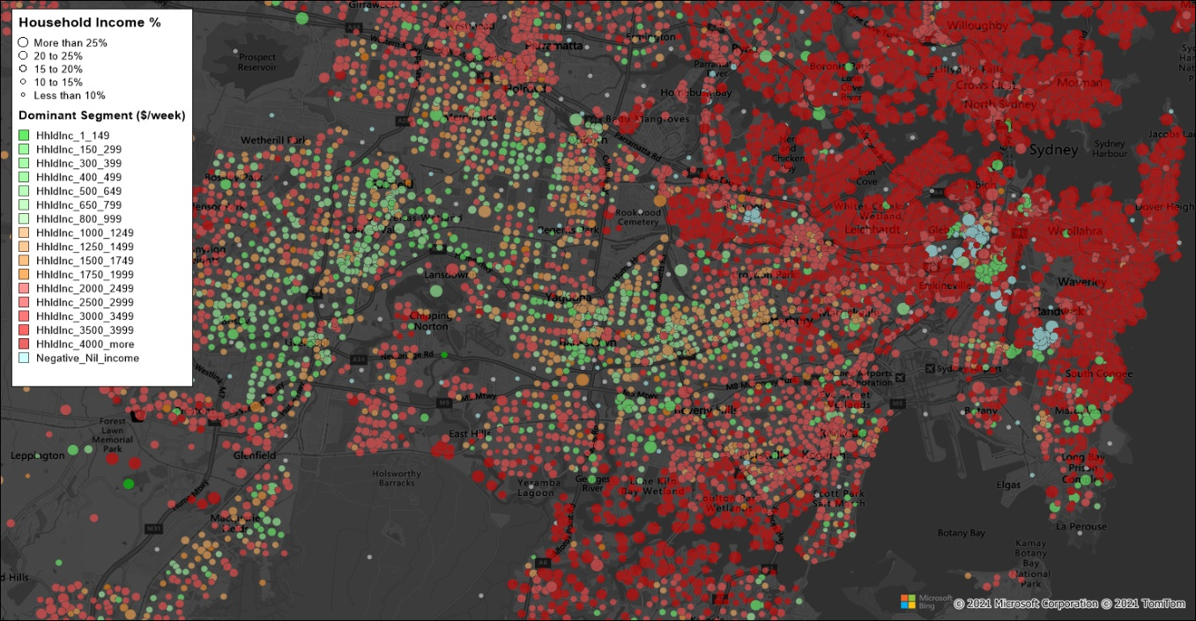

When next closing the table, the user will be asked if they want to retain or discard changes (if they haven’t already saved the table in working with it).

By choosing to save the changes the new predominance fields as well as the data within those fields will be retained.

If the user chooses to discard, the fields are retained in the dataset but are not populated with values.